EM Scan Control

Operating Instructions

Contents

Installation 1
Front Panel Description 4
Status Indicators 6
File Names and Locations 7
Operating Controls 8
Operating Instructions 10

Installation

- The EM Scan program has been designed to be as easy to install and run as possible. The following instructions will guide you through the installation and configuration process.

The first step of the installation is to decide which directories are to be used for the program, the status file and the data files it produces. These directories can be changed at any time and individual directories can be created for different test projects.

A typical arrangement is to have a master ‘EM Scan’ directory with three sub-directories, for the program, status file and test data files. Individual project directories are often created under the test data directory.

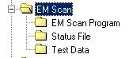

- Next load the em_scan_-_1_1.llb, virtual instrument (vi) library, into the program directory. Load the status file, ‘AxisStat.dat’, into its directory.

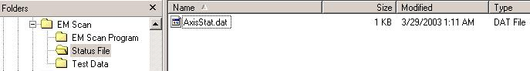

- Start LabVIEW and open the em_scan_-_1_1.llb virtual instrument (vi) library. Inside the library select and open the vi titled ‘Run EM Scan.vi’.
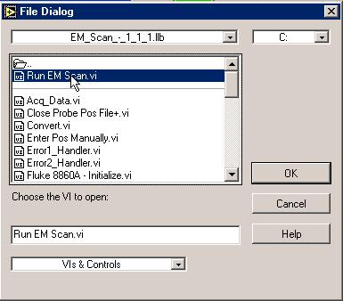
- You will now set the default directories and file names to be used by the program.
In the upper left area of the control panel are the locations for the directories and file names to be used when running the program.

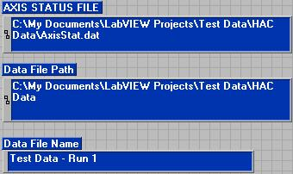

Enter the directory for the status file and the default directory for the file name and the directory for the test data.

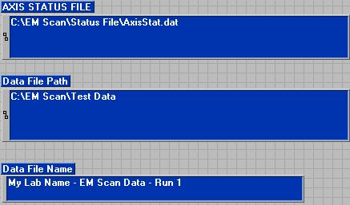

You must now set your entries to be the default value for each field. To do this right click on each of the three fields. Right click on each of the fields. Select ‘Data Operations’. Then select ‘Make Current Value Default’.

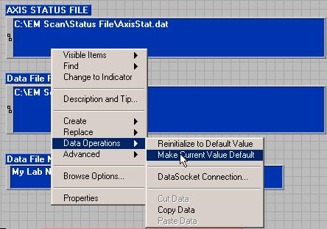

Congratulations! The program is now installed and ready to run.

Front Panel Description
- Start LabVIEW and open the em_scan_-_1_1.llb virtual instrument (vi) library. Inside the library select and open the vi titled ‘Run EM Scan.vi’.
Run EM Scan is the top level vi. This is the one you want to load. The other vi’s in the library are the various subroutines that will be called. Normally the user only opens the top level vi and operates the program from its front panel and user controls.

- When the EM Scan Control program loads you will see the following panel:

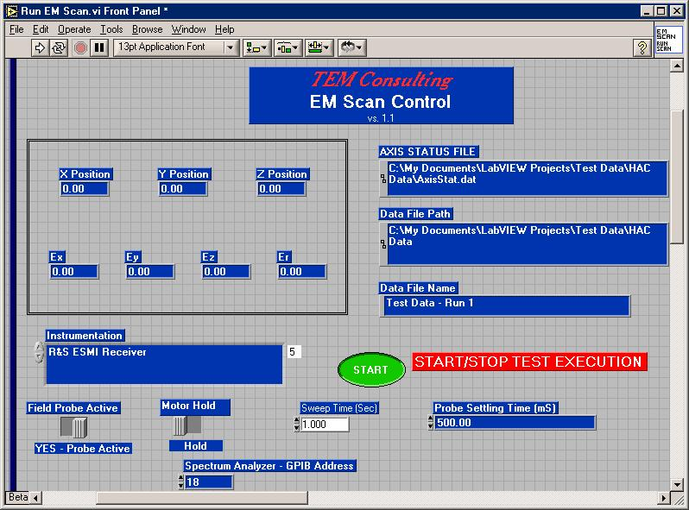

The front panel displayed is divided into three primary regions. In the upper left indictors are located that will report the current position of the probe and the current reading.
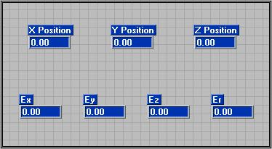

In the upper right are the path and file name for the movement status file and for the data file to be used for the next run.

On the bottom portion of the screen are the operating controls.

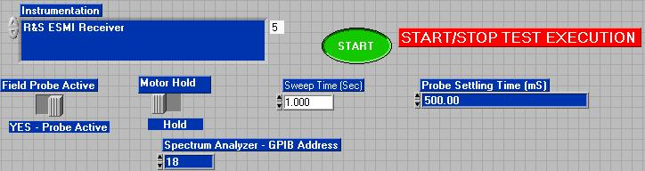

Status Indicators
The status indicators labeled ‘X Position’, ‘Y Position’ and ‘Z Position’ report the current position of the probe as the program runs. The ‘0,0,0’ position is determined during the initialization of the program.
The fields labeled ‘Ex’, ‘Ey’, ‘Ez’ and ‘Er’, are the values read from the probe. These indicators are set for a 3 element probe, which reports a separate reading in the ‘X’, ‘Y’ and ‘Z’ axis. ‘Er’ is the reading for the vector sum or total field amplitude measured. For probes which only return a single value the ‘Er’ indicator is used and the others are left reading zero.

File Names and Locations

The upper right portion of the screen is used to set the file names and locations used by the program.

The ‘Axis Status File’ is a file used by the program to record the probe location and motor state at the end of the run. This allows the program to determine the last position and resume operation from that point. When the program is first installed it is important that the location for this file be identified. After that the program will load the file at the beginning of every run and update it at the end of the run.
The ‘Data File Path’ points to the location where the data files are to be stored. ‘Data File Name’ is the file name to be used for the run. For each run two data files will be stored. The first, using the file name given, stores the data in column format. The second file, which adds a ‘z – 0’ to the file name given, stores the data in a two dimension matrix. This file format is easier to open in Excel and use for producing a contour plot of the measured values.
The directory and file name for the test data may be entered before or during program execution.

Operating Controls

The operating controls for the program are on the bottom portion of the screen.

In the Instrumentation field the instrument to be read is selected. The program provides for the following instruments:

- EMCO 7160 Field Probe
- Fluke 8860A Digital Multimeter
- HP 8568B Spectrum Analyzer w/
HP 85650A Quasi-Peak Detector
- HP 8593EM Spectrum Analyzer
- HP 8596E Spectrum Analyzer
- R&S ESMI Receiver

Other instruments can be custom added, as needed.

The ‘Field Probe Active’ can be selected to be true or false. Runs without the probe active are often done to assure that the desired scan area has been selected. Then actual tests runs are made, recording the data.

The ‘Motor Hold’ field determines where the stepper motors will be held dynamically in position when not moving or be left non-energized. Holding the motors energized has the advantage of presenting slipping when that particular axis is not moving. However, holding tension on a motor means that current is still feed to the motor, which creates electromagnetic fields, which may interfere with some very sensitive readings. It is recommended that the option to hold the motors be selected unless interference with the readings is detected.

The ‘Spectrum Analyzer – GPIB Address’ is the address to be used in addressing an instrument on the GPIB bus. Note that this address is only used for instruments controlled over the GPIB bus.

The ‘Probe Settling Time (ms)’ sets a value between the movement of a probe to a new position and when the instrument will be interrogated for the reading at that position. The settling time should be set to allow for any vibration created by the movement of the probe to settle and for the probe to take a new reading at the current position.

Operating Instructions
- Start LabVIEW and open the em_scan_-_1_1.llb virtual instrument (vi) library. Inside the library select and open the vi titled ‘Run EM Scan.vi’.
Run EM Scan is the top level vi. This is the one you want to load. The other vi’s in the library are the various subroutines that will be called. Normally the user only opens the top level vi and operates the program from its front panel and user controls.

- Set the controls to the values to be used for the test.

  - Set the directory and file name to be used to store the test data taken during the test.
  - Select the instrument that will be delivering the probe data.
  - Set the other controls to the desired position for the test to be run.

- To run the program you must first start it under LabVIEW. This is done by clicking on the ‘run’ arrow on the top menu bar.

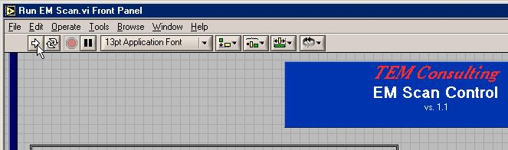

Then click on the ‘Start’ button on the control panel.
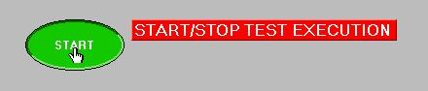

- The first screen you will see when the program starts is the ‘Rectangular Movement Initialization’ screen. This screen is used to set the area to be scanned and the interval between readings.

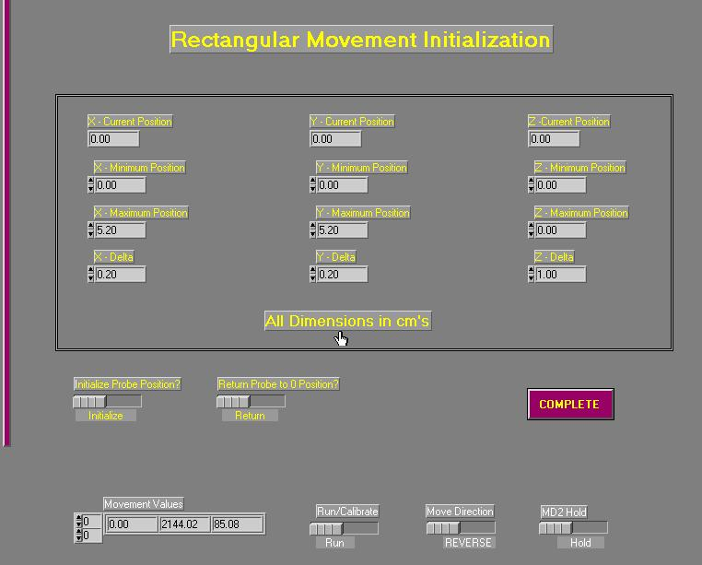

The ‘X – Current Position’, ‘Y – Current Position’ and ‘Z - Current Position’ fields reports the location the program has as the current probe position. This location is initially derived from the status file, when the program starts. The probe may be moved to a new location to align the location recorded by the program with its physical location.

The ‘X – Minimum Position’, ‘Y – Minimum Position’ and ‘Z - Minimum Position’ fields are used to set the starting position for each axis.

The ‘X – Maximum Position’, ‘Y – Maximum Position’ and ‘Z - Maximum Position’ fields are used to set the ending position for each axis.

The ‘X – Delta’, ‘Y – Delta’ and ‘Z - Delta’ fields set the step size. This is the movement distance between readings. The program will move the probe in one axis, one step and then take a reading. The program continues this process of moving and reading until the entire volume selected has been scanned.

The ‘Initialize Probe Position?’ and ‘Return Probe to 0 Position?’ controls give options on the program operation.

Once the proper values are entered click on the complete button.



- A dialogue box will appear that prompts you to position the probe and EUT in the correct relative position to start the scan. Once you are satisfied that the EUT is in the correct position for the scan and is operating as intended for the test, click on the ‘OK’ button.

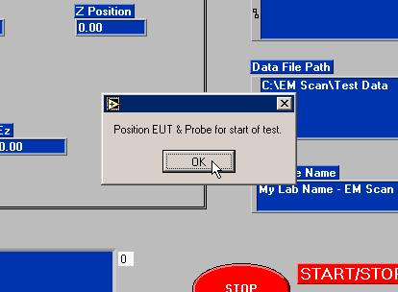

- If a probe is selected that uses a spectrum analyzer a screen will be presented that allows the configuration of the instrument.
Set the various controls and click on the ‘SET’ button until the spectrum analyzer is configured as desired for the test. This cycle of changing the settings and selecting ‘SET’ is often repeated several times before the spectrum analyzer is configured to best support the test.

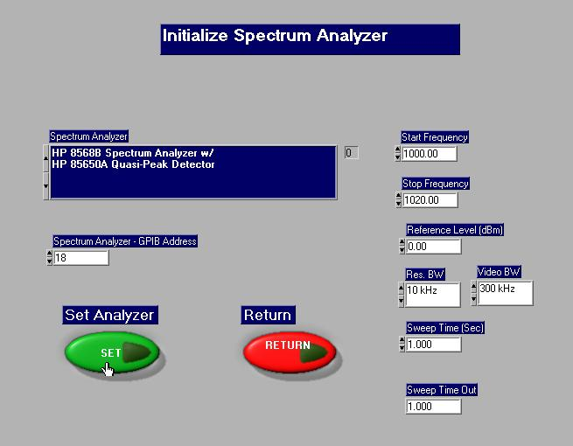

When you are satisfied with the configuration select the ‘RETURN’ button to start the test.

- The program will now begin to run, moving the probe and taking readings until the scan is complete.

