ANSI ASC 63

Ferrite Clamp Requirement
Proposed Revision to

ANSI C63.4

Revision 4 – May 17, 2002

Proposed modifications to ANSI C63.4-2000 to incorporate ferrite clamps for table top equipment measurements.

1. Add a new section, 4.4.6, as follows:

4.4.6 Ferrite clamp characteristics

Ferrite, in the form of clamps, tubes or individual ferrites, (ferrite clamps) placed on cables leaving a tabletop EUT for connection outside the test area shall meet the following specifications:
- The insertion loss of the ferrite clamps shall be >15 dB in the frequency range 30 MHz to 1000 MHz when measured in a 50 Ω system according to CISPR 16-1.
- The input impedance of a wire through the ferrite clamp shall meet the following values when measured according to Annex N of this standard:

Frequency Impedance (output shorted to ground)
MHz Ohms

30 1700
50 600
100 600
1000 200

The tolerance on these impedance values shall be +/- 100 Ω

2. Amend Figure 11a to add ferrite clamps to the three cables shown reaching the floor. Label them with the numeral ‘9’ and add the following text to the Legend:

9. Ferrite clamps with similar characteristics (as defined in 4.4.6).

Multiple cables of the same cable type, from the same type of interface, may be routed through a single ferrite clamp. The exact configuration is to be documented in the test report. In case of dispute, the EUT must be re-measured using the original documented ferrite clamp configuration.

3. Add the following text as a new paragraph at the end of 6.2.1.3:

All cables leaving the tabletop EUT for a connection outside the test site (e.g., power cords, telephone lines, data connections to auxiliary equipment located outside the test area) shall be routed through ferrite clamps placed on the floor at the point where the cable reaches the floor (see Figure 11a). The cable shall be at least 2” above the groundplane at the point it enters the ferrite clamp. The characteristics of the clamps or tubes shall be as defined in section 4.4.6.

4. Amend Figure 14 to add a ferrite clamp to the cable shown reaching the floor from the table top EUT. Label the clamp with the numeral ‘9’ and add the following text to the Legend:

- Ferrite clamps or ferrite tubes with similar characteristics (as defined in 4.4.6).

Multiple cables of the same cable type, from the same type of interface, may be routed through a single ferrite clamp. The exact configuration is to be documented in the test report. In case of dispute, the EUT must be re-measured using the original documented ferrite clamp configuration.

5. Add the following text as a new paragraph at the end of 11.2.4:

All cables leaving the tabletop EUT for a connection outside the test site (e.g., power cords, telephone lines, data connections to auxiliary equipment located outside the test area) shall be routed through ferrite clamps placed on the floor at the point where the cable reaches the floor (see Figure 11a). The cable shall be at least 2” above the groundplane at the point it enters the ferrite clamp. The characteristics of the clamps or tubes shall be as defined in section 4.4.6.

6. Rename Annex N as Annex O and amend the Table of Contents to show Annex N as Annex O.

7. Insert a new Annex N into the Table of Contents with the title – “Annex N (normative) Ferrite Clamp Calibration Method

8. Add a new Annex N as follows:

Annex N

(normative)

Ferrite Clamp (or Tube) Calibration Method

The ferrite clamp or tube shall be calibrated for insertion loss and input impedance for a wire passing through the clamp or tube as described below. The clamp or tube shall be installed in a calibration jig for both tests.

N.1 Insertion loss

Equipment required:

Signal generator
30 MHz to 1 GHz
Unmodulated
Output level adequate to provide a signal at least 55 dB above the receiver noise floor
50 Ω output impedance

Receiver
Spectrum analyzer or receiver
30 MHz to 1 GHz
Peak detector
50 Ω input impedance

50 Ω Attenuators (2 ea)
10 dB insertion loss
Type “N” connectors

Calibration jig
See figures N.1, N.2 and N.3 for details,

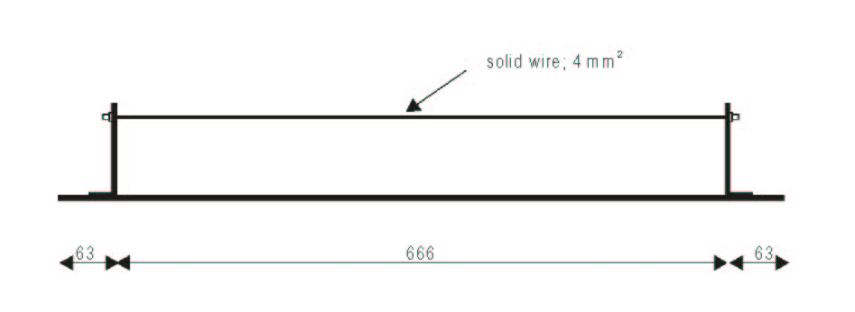

Figure N.1 Side view of the calibration jig (all dimensions in mm)

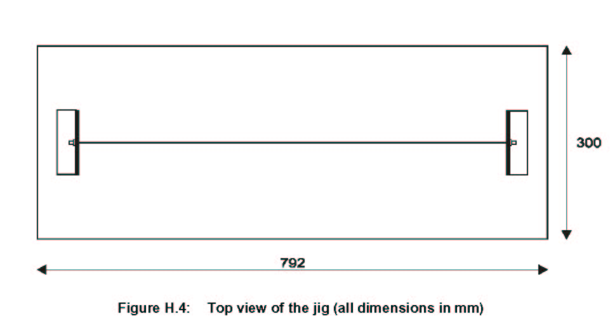

Figure N.2 Top view of the jig (all dimensions in mm)

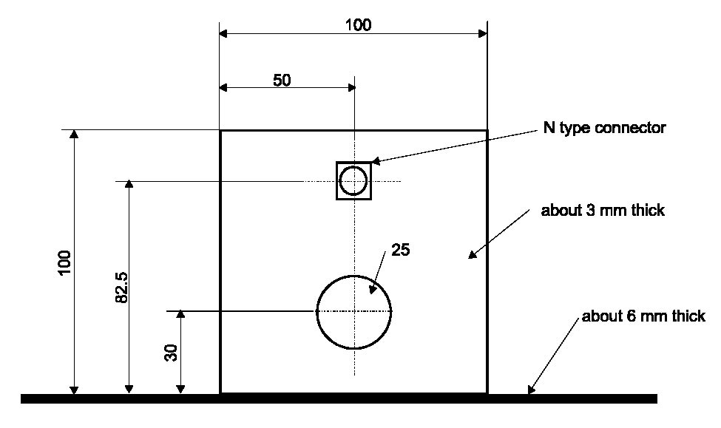

Figure N.3 Side view of the jig (all dimensions in mm)

The insertion loss of the ferrite clamp shall be measured using the following steps:

1. Connect the attenuators end to end between the output of the signal generator and the input of the receiver. Measure the loss in the cable/attenuator system.

2. Install the ferrite clamp or tubes in the calibration jig. Center the jig wire in the center of the ferrite clamp opening. Break the connection between the two attenuators and connect the attenuator at the end of the cable from the signal generator to one end of the calibration jig and the attenuator at the end of the cable from the receiver to the other end of the calibration jig.

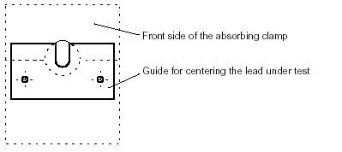
Position of guide for centering the lead under test

3. Measure the loss of the system.

4. Subtract the results obtained in step 1 from the results obtained in step 3. Check to see that all results of this calculation are greater than 15 dB.

N.2 Input impedance

Equipment required:

Vector network analyzer with S parameter test set

Calibration jig (see figures N.1, N.2 and N.3 above)

The input impedance for the wire passing through the ferrite clamp or tube shall be measured as follows:

1. Install the ferrite clamp or tubes in the calibration jig. After calibrating the network analyzer at the end of its cable to the calibration jig, connect the network analyzer to one port of the calibration jig. Short the second port of the calibration jig to the metal end plate of the jig with as short a connection as possible. (e.g., a calibrated short from the network analyzer calibration kit could be used for this purpose.)

2. Measure the input impedance of the ferrite clamp in the calibration jig from 30 MHz to 1000 MHz.

3. Compare the input impedance data to the following data points:

Frequency Impedance (output shorted to ground)
MHz Ohms

30 1700
50 600
100 600
1000 200

The tolerance on these impedance values shall be +/- 100 Ω

N.3 Measurement frequencies

All measurements in this annex shall be made using frequency intervals no larger than the following:
- 1 MHz steps from 30 MHz to 60 MHz,
- 2 MHz steps from 60 MHz to 120 MHz,
- 5 MHz steps from 120 MHz to 300 MHz
- 10 MHz steps from 300 MHz to 1 GHz.

N.4 Calibration uncertainties

The calibration uncertainty of the ferrite clamp depends on:

1. The measurement uncertainty of the measurement equipment

- The repeatability of the measurement, which includes the centering of the lead through the ferrite clamp.

N.5 Measurement uncertainties

- The relationship between the inside diameter of the opening in the ferrite clamp and the outside diameter of the cable passing through it.

Figures copied from Figures H.3, H.4 and H.5 in CISPR/A/338/CD.
All measurements on the calibration fixture are ±5%.

