Impedance measurements on the absorbing clamps MDS21 and AMZ41

- MDS21, SN.863327/016

1.1 Calibration reference point: end of the cable from the NA to the fixture

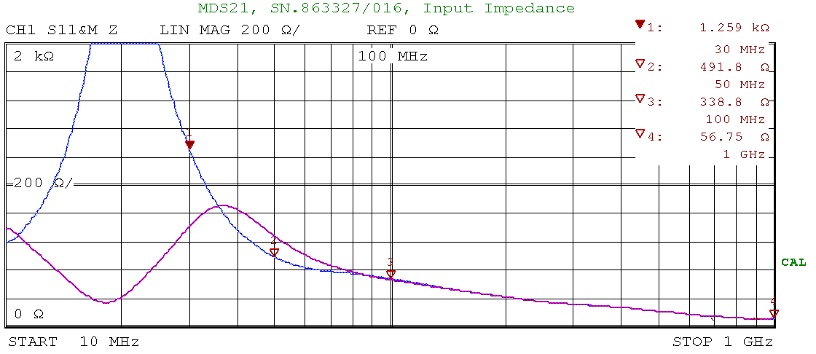
Figure 1: MDS21_03a.bmp
Distance between fixture and first ferrite 30mm

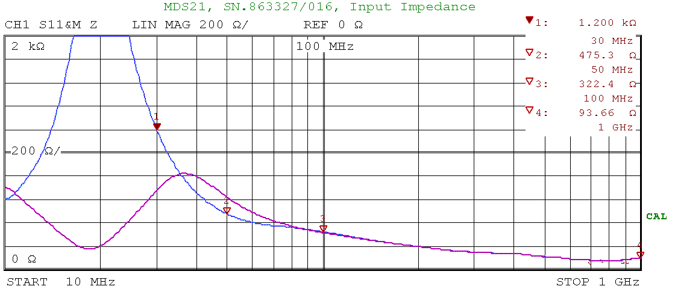

Figure 2: MDS21_05a.bmp
Distance between fixture and first ferrite 50mm

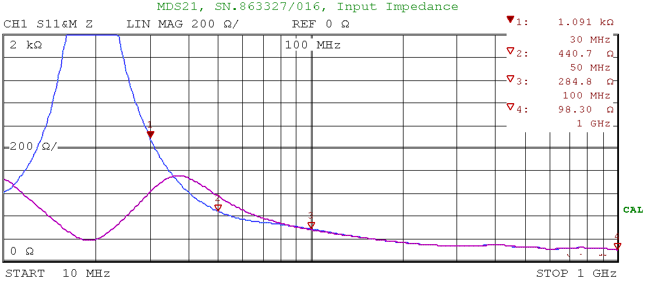

Figure 3: MDS21_10a.bmp
Distance between fixture and first ferrite 100mm

1.2 Calibration reference point: end of the fixture (input aperture of the CMAD)

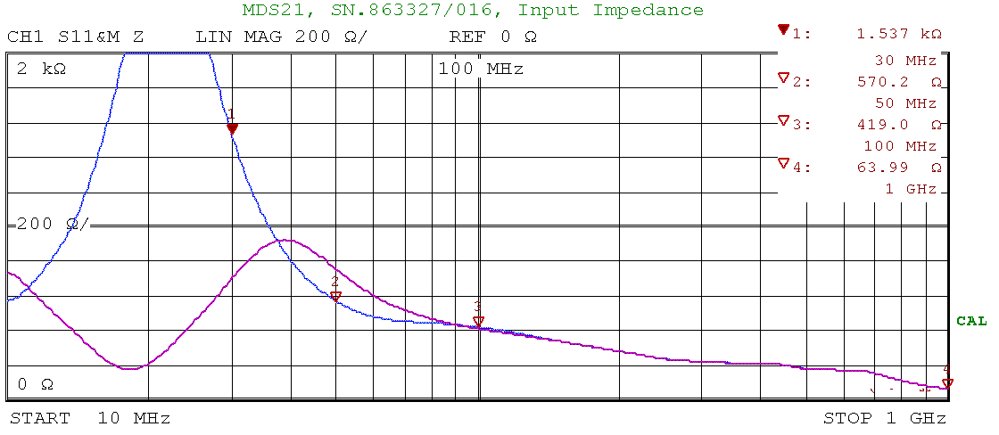
Figure 4: MDS21_03b.bmp
Distance between fixture and first ferrite 30mm

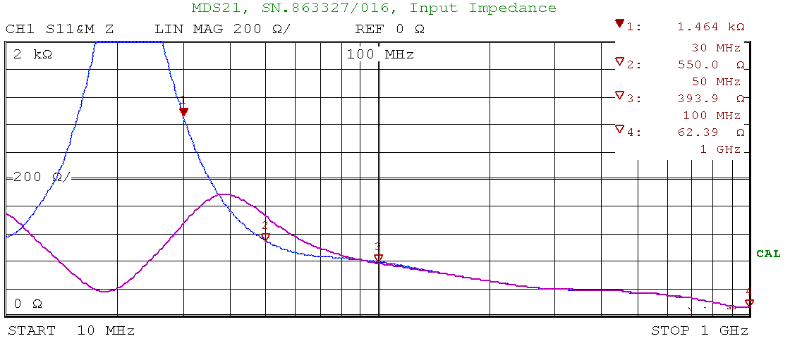

Figure 5: MDS21_05b.bmp
Distance between fixture and first ferrite 50mm

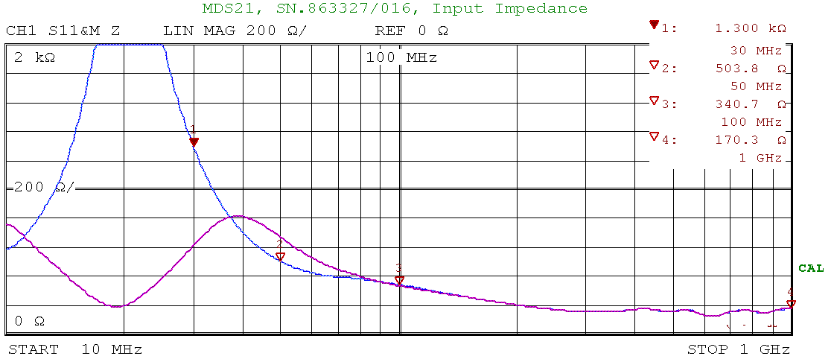

Figure 6: MDS21_10b.bmp
Distance between fixture and first ferrite 100mm

Blue trace: end of the test wire is shorted to the ground reference plane on the second fixture
Red trace: end of the test wire is open on the second fixture

Heigth of the test wire above the ground reference plane: 65mm
Fixture is in accordance to IEC1000-4-6 (height changed to 65mm)
Diameter of the test wire: 4mm (solid wire)
Lenght of the test wire: 75cm

- AMZ41, SN.19165

2.1 Calibration reference point: end of the cable from the NA to the fixture

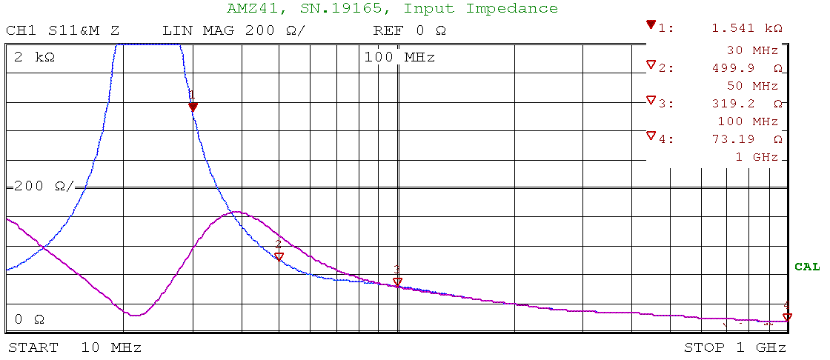
Figure 7: AMZ41_03a.bmp
Distance between fixture and first ferrite 43mm

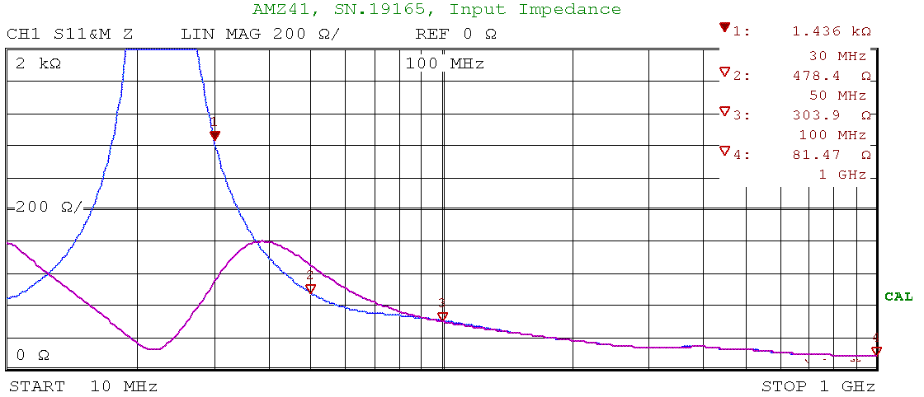

Figure 8: AMZ41_05a.bmp
Distance between fixture and first ferrite 63mm

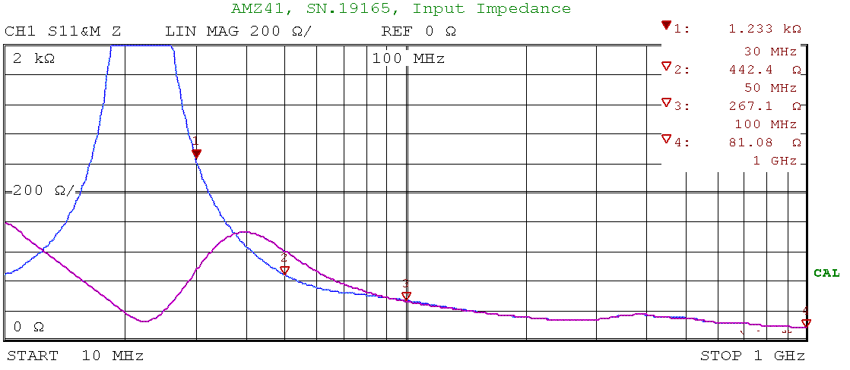

Figure 9: AMZ41_10a.bmp
Distance between fixture and first ferrite 113mm

2.2 Calibration reference point: end of the fixture (input aperture of the CMAD)

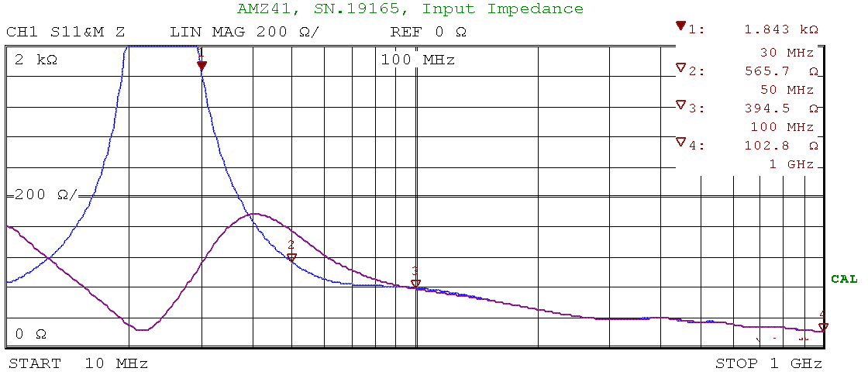
Figure 10: AMZ41_03b.bmp
Distance between fixture and first ferrite 43mm

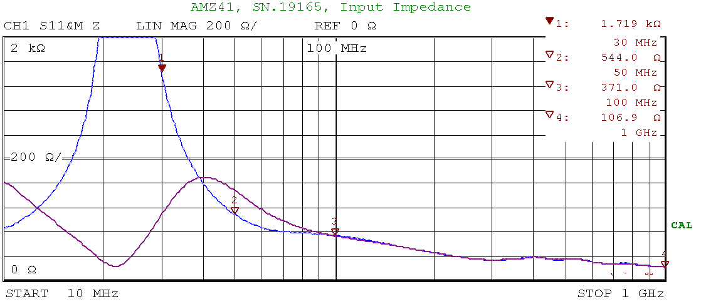

Figure 11 AMZ41_05b.bmp
Distance between fixture and first ferrite 63mm

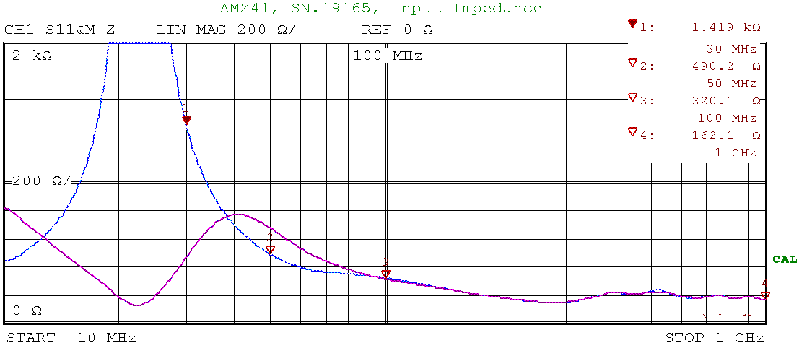

Figure 12: AMZ41_10b.bmp
Distance between fixture and first ferrite 113mm

Blue trace: end of the test wire is shorted to the ground reference plane on the second fixture
Red trace: end of the test wire is open on the second fixture

Heigth of the test wire above the ground reference plane: 65mm
Fixture is in accordance to IEC1000-4-6 (height changed to 65mm)
Diameter of the test wire: 4mm (solid wire)
Lenght of the test wire: 75cm

