Impedance measurements on two samples of the absorbing clamp MDS21

- MDS21, SN.863327/015

1.1 Calibration reference point: end of the cable from the NA to the test jig

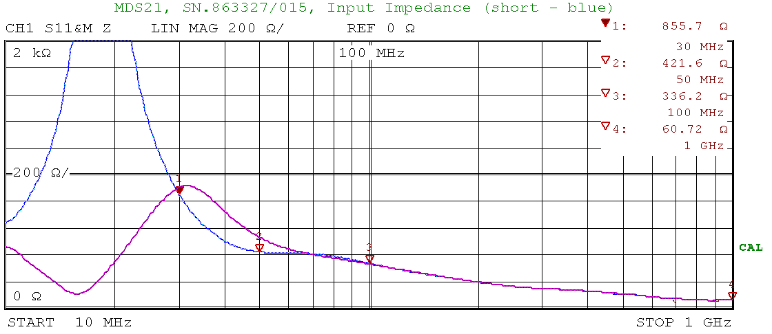
Figure 1: MDS21_15_a.bmp

1.2 Calibration reference point: end of the test jig (input aperture of the CMAD)

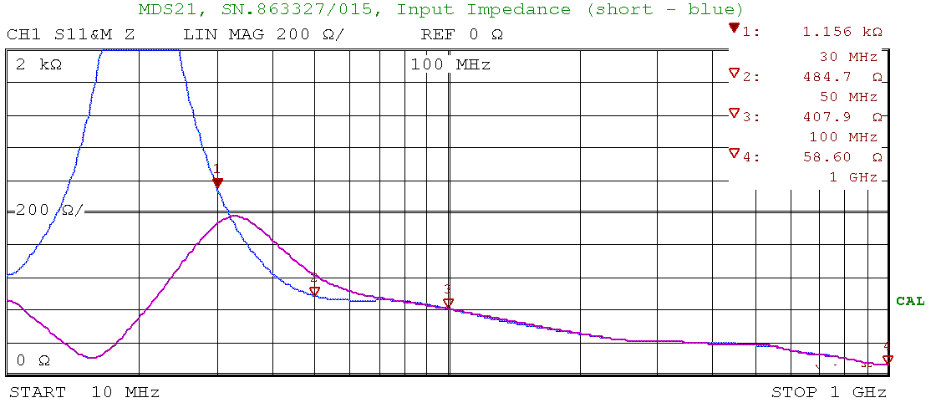

Figure 2: MDS21_15_b.bmp

Blue trace: end of the test wire is shorted to the ground reference plane on the second test jig
Red trace end of the test wire is open on the second test jig

Heigth of the test wire above the ground reference plane: 65mm
Distance between test jig and CMAD: 25mm (first ferrite – 32mm)
Test jig is in accordance to IEC1000-4-6 (height changed to 65mm)
Diameter of the test wire: 4mm (RG58 coaxial cable)
Lenght of the test wire: 80cm

- MDS21, SN.863327/016

2.1 Calibration reference point: end of the cable from the NA to the test jig

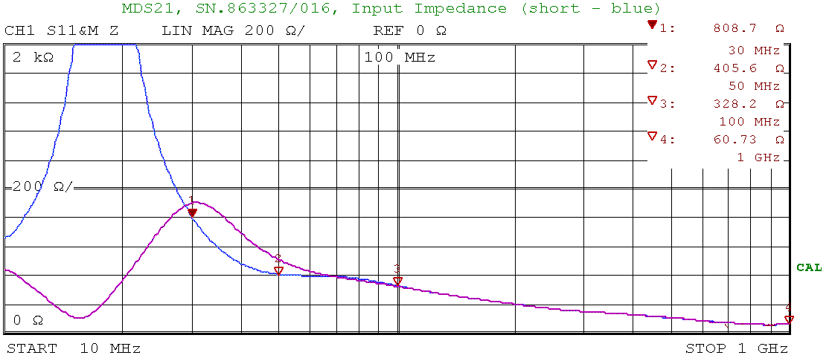
Figure 3: MDS21_16_a.bmp

2.2 Calibration reference point: end of the test jig (input aperture of the CMAD)

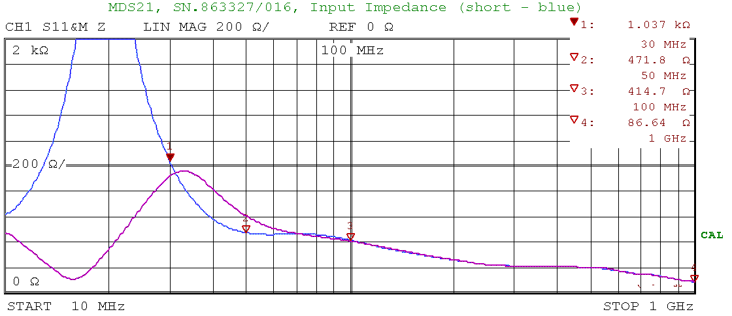

Figure 4: MDS21_16_b.bmp

Blue trace: end of the test wire is shorted to the ground reference plane on the second test jig
Red trace end of the test wire is open on the second test jig

Heigth of the test wire above the ground reference plane: 65mm
Distance between test jig and CMAD: 25mm (first ferrite – 32mm)
Test jig is in accordance to IEC1000-4-6 (height changed to 65mm)
Diameter of the test wire: 4mm (RG58 coaxial cable)
Lenght of the test wire: 80cm

