Modulation Envelopes and Audio Frequency Spectra of Various Transmission Protocols

Stephen Julstrom – August 1, 2008

- The waveform and spectrum plots were generated in VisSim. The spectrum plots do not include the DC (0 Hz) component.

- The sinewave modulation was generated purely mathematically within the program. All the others were input from 2 second long, 44.1 kHz, 16-bit sampled, mono .wav files.

- The FHSS and DSSS modulations pertain to cordless phones. They were generated as pure pulses mathematically in Matlab. The validity of this approach was independently checked to confirm that the generated spectra closely matched that recorded from sample cordless phones (recorded by Al Baum of Uniden).

- The cellphone modulation waveforms were generated from computer simulations of the modulation. The waveform plots exhibit some visible artifacts on the pulse edges that should be attributed to the effects of the sharp ~20 kHz band-limiting associated with the 44.1 kHz sampling. Some of the modulations have several sub-variants, of which only one is represented.

- The vertical scaling of the plots can be considered arbitrary, except that there is a relation among the various modulation plots (with the exception of the sinewave modulation plots). The .wav files that generated the plots were all normalized to yield the same A-weighted, telecoil response (1st order rolloff below 1 kHz) levels. Even though RF detection of the envelopes (in contrast to baseband magnetic telecoil pickup) would not include the telecoil response rolloff but would add square-law detection, and even though A-weighting is arguably not the best predictor of subjective annoyance/audibility, it is still valid to view the plots on the basis that the comparative levels represent roughly equal contributions to audio frequency annoyance/audibility.

- Although the frequency axis of the spectrum plots is shown as linear rather than the common logarithmic presentation (because it makes the harmonic structure more apparent), it should be kept in mind that the most relevant frequency range for the target population of hearing device users could be considered to center on roughly the 300 Hz to 3 kHz range.

Thanks to Lou Vannatta of Motorola for the modulation simulations and Scott Isabelle of Motorola for the .wav file processing and generation.

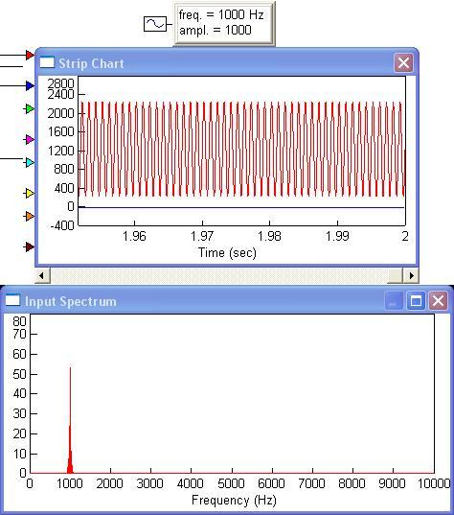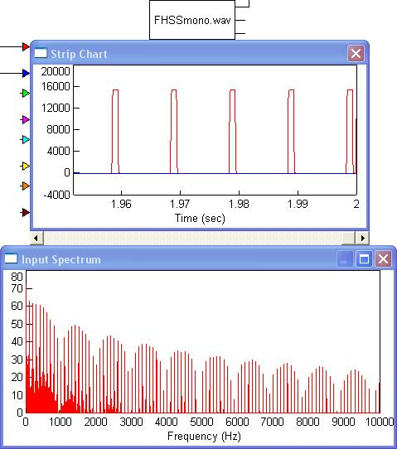

1 kHz, 80% sinewave modulation generates a single spectral line at 1 kHz upon detection (ignoring the DC component). (Square law detection would add the 2nd harmonic at 2 kHz, 14 dB below the fundamental.)

Cordless phone FHSS can be represented within the audio band as a pure pulse 1 msec long, occurring every 10 msec. The 100 Hz repetition rate results in energy at 100 Hz and its harmonics, with nulls every 10th harmonic (frequency multiples of 1/pulse width). The sound is a low, clean buzz.

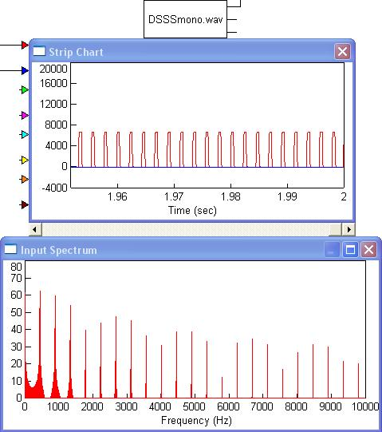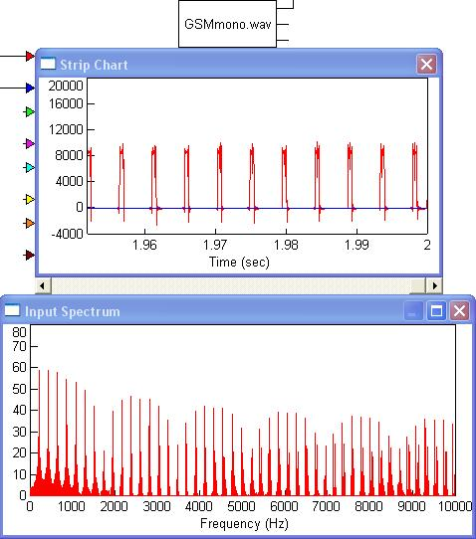

Similarly, cordless phone DSSS has pulses with a 445 Hz repetition rate that are about 525 μsec long, giving spectrum nulls about every 1.9 kHz. The sound is an electronic, medium-pitched tone (just above A=440 Hz).
GSM’s pulses occur at a 217 Hz rate, with a 1/8 duty cycle, giving a null every 8th harmonic. The familiar sound is a medium-low pitched buzz.

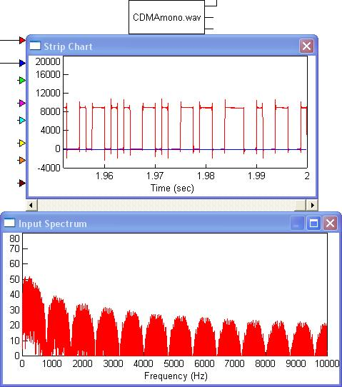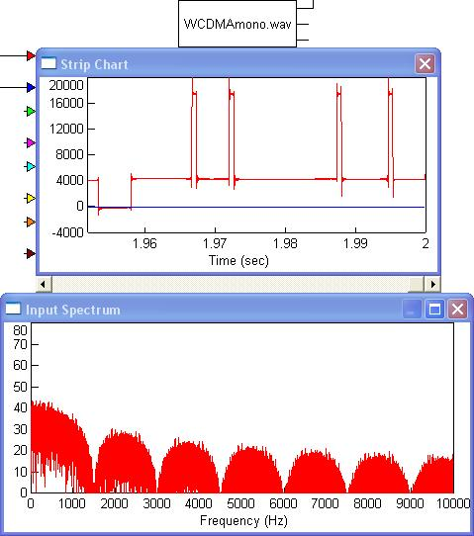

CDMA’s pulses have a basic width at multiples of 1.25 msec, giving spectrum nulls at multiples of 800 Hz. The randomization of the pulses spreads any discrete spectral lines. The sound has a rough, midrange-y mechanical quasi-tonality.
The pulse randomization occurs with WCDMA, also, but the basic pulse width of .67 msec yields spectrum nulls at multiples of 1.5 kHz. The wide spacing of the pulses results in a more “static-y”, raspy character to the sound.

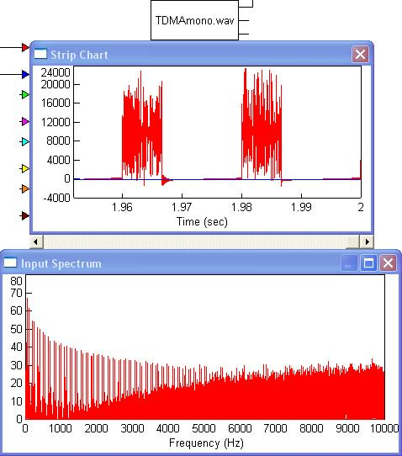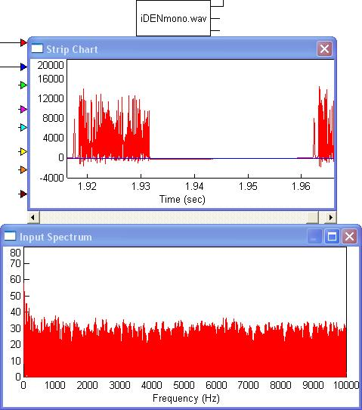

TDMA’s pulse rate is 50 Hz with a 1/3 duty cycle, which gives nulls every third harmonic, but there is considerable audio frequency modulation within each pulse. The symbol rate is 24.6 kHz (?), which spreads components throughout the upper audio frequency range. The sound is a simultaneous very low frequency buzz and high frequency hiss.
The iDEN sample has bursts of modulation apparently up from a zero level, at a 22 Hz rate and 1/3 duty cycle. Within the bursts, the symbol rate is 4 kHz (?), spreading noise throughout the audio band. The pulse repetition rate is slow enough that individual bursts of noise are heard.

