Date: | July 30, 2026
From: | Stephen Berger |  | Phone | (512) 864-3365
Subject: | LTE Transmission Envelop

LTE Transmission Envelop
The following data was taken to explore the variation in the LTE waveform possible on current 3G networks. The data was taken with the device configured to send 10 pings, once per second, with 64 bytes per ping. Even through all six of the transmissions were identical from the viewpoint of the data being sent from the device the interaction with the network resulted in very different waveforms.
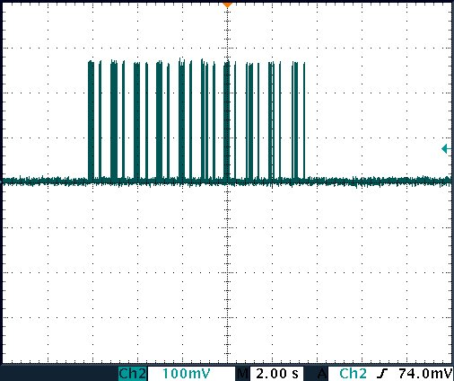  Figure 1 - Burst Transmission #1 | 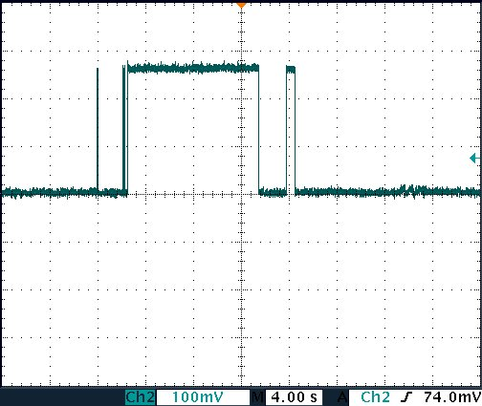  Figure 2 - Burst Transmission #2
As can be see in Figure 1 the transmission can be comprised of a number of short bursts. The timescale of these measurements was 2 sec/div. The sorter bursts have a duration of 4 to 40 ms or 25 to 250 Hz. This would predict the RF audio interference would be lower in the audio frequency band.
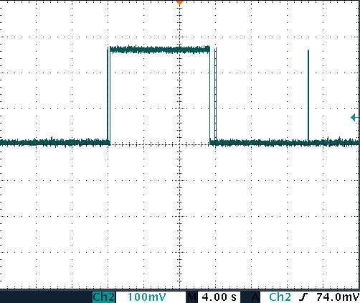  Figure 3 - Burst Transmission #3 | 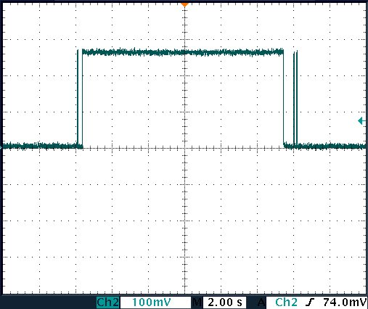  Figure 4 - Burst Transmission #4

As can be seen in the other waveform recordings, particularly Figure 4, the network can configure the device for a long transmission, resulting in the transmitter being continuously on. This waveform would be less interfering as there is little energy demodulated into the audio frequency band.
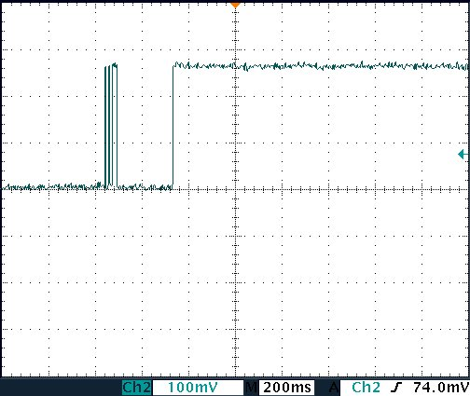  Figure 5 - Burst Transmission #5 | 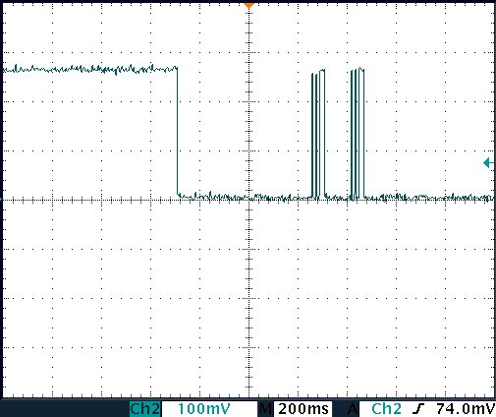  Figure 6 - Burst Transmission #6
A single ping can result in a bursty waveform or result in the transmitter being continually on for several seconds. In these tests all DNS resolution is on the unit (via hosts file), so the ping request and acknowledgment are the only IP packets the transmitter is requested to send.

